Unit 1
Grammar: Direct and indirect questions
Exercise 1
Complete the sentences
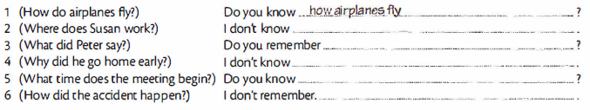
Exercise 2

